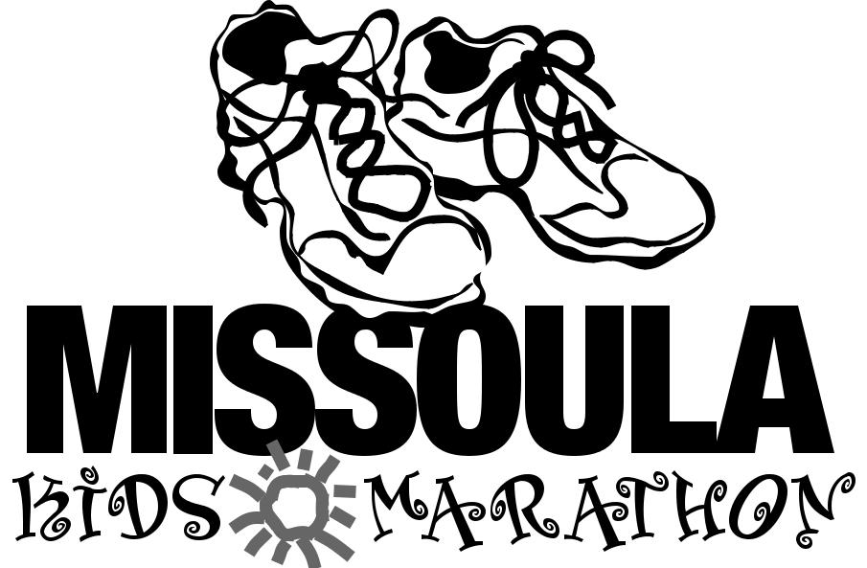

First: Starting April 1st, run, jog, hike, swim or roll 25 miles before race day. Have an adult or parent sign for each mile.

Second: In addition to your training runs, run local races to add mileage to your log such as the Riverbank Run and Run for the Trees. Do both races and you can register for the MKM for free! Check the Run Wild Missoula website for more listings of local runs.

Third: Bring your log sheet or proof of registration and run a final training lap at Washington Grizzly Stadium on Thursday, June 2,

Start➤ |  |  |  |  | Adult Initials➤
 |  |  |  |  | 1 mile
.25 |  | .25 | .25 | .25
 |  |  |  |  | 2 mile
.25 |  | .25 | .25 | .25
 |  |  |  |  | 3 mile
.25 |  | .25 | .25 | .25
 |  |  |  |  | 4 mile
.25 |  | .25 | .25 | .25
 |  |  |  |  | 5 mile
.25 |  | .25 | .25 | .25
 |  |  |  |  | 6 mile
.25 |  | .25 | .25 | .25
 |  |  |  |  | 7 mile
.25 |  | .25 | .25 | .25
 |  |  |  |  | 8 mile
.25 |  | .25 | .25 | .25
 |  |  |  |  | 9 mile
.25 |  | .25 | .25 | .25
 |  |  |  |  | 10 mile
.25 |  | .25 | .25 | .25
 |  |  |  |  | 11 mile
.25 |  | .25 | .25 | .25
 |  |  |  |  | 12 mile
.25 |  | .25 | .25 | .25
 |  |  |  |  | 13 mile
.25 |  | .25 | .25 | .25

2011. Gate opens at 5:00 PM, run begins at 5:30 PM. Pick up your official race t-shirt, race number, and get your picture taken on the field. If you CANNOT come to the final training run, you can pick up your t-shirt and race number at the Carousel on Friday, July 8, 2011 from 5pm to 7pm.

Fourth: Come run the final 1.2 miles of your marathon and pick up your medal and goodie bag at the Missoula Kids Marathon fun run at 10:00 AM on Saturday, July 9, 2011. Check the website before race day to verify the start time and location. Plan to arrive early to find your place and warm up.

 |  |  |  | Adult Initials➤
 |  |  |  | 14 mile
.25 | .25 | .25 | .25
 |  |  |  | 15 mile
.25 | .25 | .25 | .25
 |  |  |  | 16 mile
.25 | .25 | .25 | .25
 |  |  |  | 17 mile
.25 | .25 | .25 | .25
 |  |  |  | 18 mile
.25 | .25 | .25 | .25
 |  |  |  | 19 mile
.25 | .25 | .25 | .25
 |  |  |  | 20 mile
.25 | .25 | .25 | .25
 |  |  |  | 21 mile
.25 | .25 | .25 | .25
 |  |  |  | 22 mile
.25 | .25 | .25 | .25
 |  |  |  | 23 mile
.25 | .25 | .25 | .25
 |  |  |  | 24 mile
.25 | .25 | .25 | .25
 |  |  |  | 25 mile
.25 | .25 | .25 | .25

FINISH YOUR MARATHON ON RACE DAY!

Any Questions? Visit: www.missoulakidsmarathon.org

