Save
the
Date
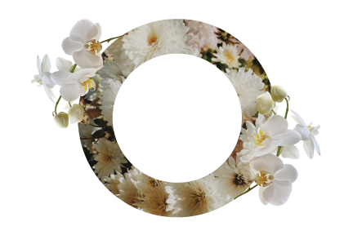

YOU ARE JOYFULLY INVITED
TO THE WEDDING CELEBRATION OF
Laura And Peter
Day / Month / Year
00:00 PM

Address

