 |  |  |  |  |  |  |  |  |  | VARIOUS ITEMS
 |  |  |  |  |  |  |  |  |  | Summer 2020 Collection
 |  | 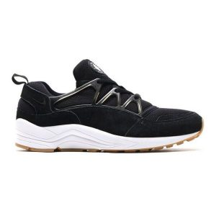 |  |  | DUMMY PRODUCT #1 |  |  | 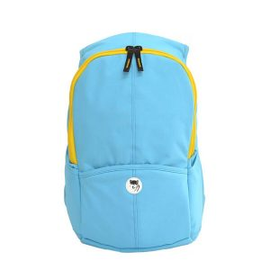 |  |  |  |  |  |  |  |  |  | DUMMY PRODUCT #2
 |  |  |  |  | ID: 202256 |  |  |  |  |  |  |  |  |  |  |  |  | ID: 202250
 |  |  |  |  | Wholesale Price: |  |  |  |  |  |  |  |  |  |  |  |  | Wholesale Price:
 |  |  |  |  | $45.99 |  |  |  |  |  |  |  |  |  |  |  |  | $32.99
 |  |  |  |  | Materials: |  |  |  |  |  |  |  |  |  |  |  |  | Materials:
 |  |  |  |  | Rubber, Leather, Synthetics |  |  |  |  |  |  |  |  |  |  |  |  | Synthetics
 |  |  |  |  | Colours: |  |  |  |  |  |  |  |  |  |  |  |  | Colours:
 |  |  |  |  | Black/Grey |  |  |  |  |  |  |  |  |  |  |  |  | Blue/Yellow
 |  | 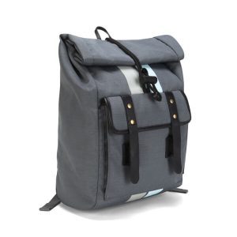 |  |  | DUMMY PRODUCT #3 |  |  |  |  |  | 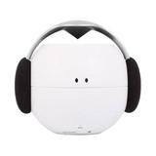 |  |  |  |  |  |  |  |  |  | DUMMY PRODUCT #4
 |  |  |  |  | ID: 202240 |  |  |  |  |  |  |  |  |  |  |  |  |  |  |  | ID: 202230
 |  |  |  |  | Wholesale Price: |  |  |  |  |  |  |  |  |  |  |  |  |  |  |  | Wholesale Price:
 |  |  |  |  | $69.99 |  |  |  |  |  |  |  |  |  |  |  |  |  |  |  | $29.99
 |  |  |  |  | Materials: |  |  |  |  |  |  |  |  |  |  |  |  |  |  |  | Materials:
 |  |  |  |  | Leather, Synthetics |  |  |  |  |  |  |  |  |  |  |  |  |  |  |  | Plastic/Synthetics
 |  |  |  |  | Colours: |  |  |  |  |  |  |  |  |  |  |  |  |  |  |  | Colours:
 |  |  |  |  | Black/Grey |  |  |  |  |  |  |  |  |  |  |  |  |  |  |  | Black/White/Grey
 |  |  |  |  | DUMMY PRODUCT #5
 |  |  |  |  | ID: 202220
 |  |  |  | Wholesale Price:
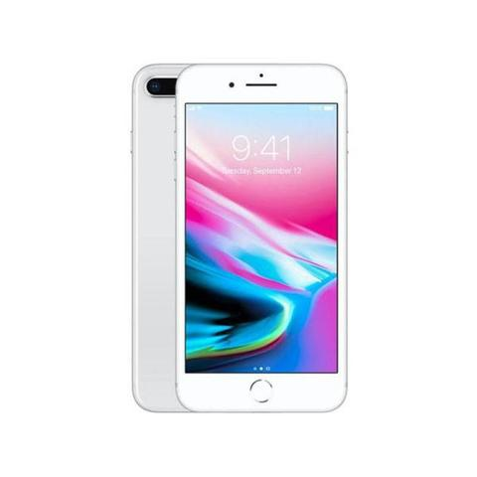
$125.99
 |  |  |  | Materials:
 |  |  |  | Electrical device
 |  |  |  | Colours:
 |  |  |  | White
 | 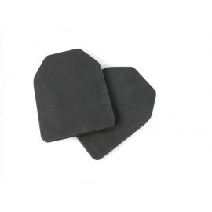 |  |  | DUMMY PRODUCT #7
 |  |  |  | ID: 202289
 |  |  |  | Wholesale Price:
 |  |  |  | $12.99
 |  |  |  | Materials:
 |  |  |  | Rubber
 |  |  |  | Colours:
 |  |  |  | Black
 |  | www.companyname.com |  |  |  | COMPANY NAME |  |  |  |  |  |  |  |  |  |  |  |  |  |  |  |  |  |  |  | Phone: (555) 215 6589
 |  |  |  |  |  | Type your slogan here. Lorem Ipsum.

