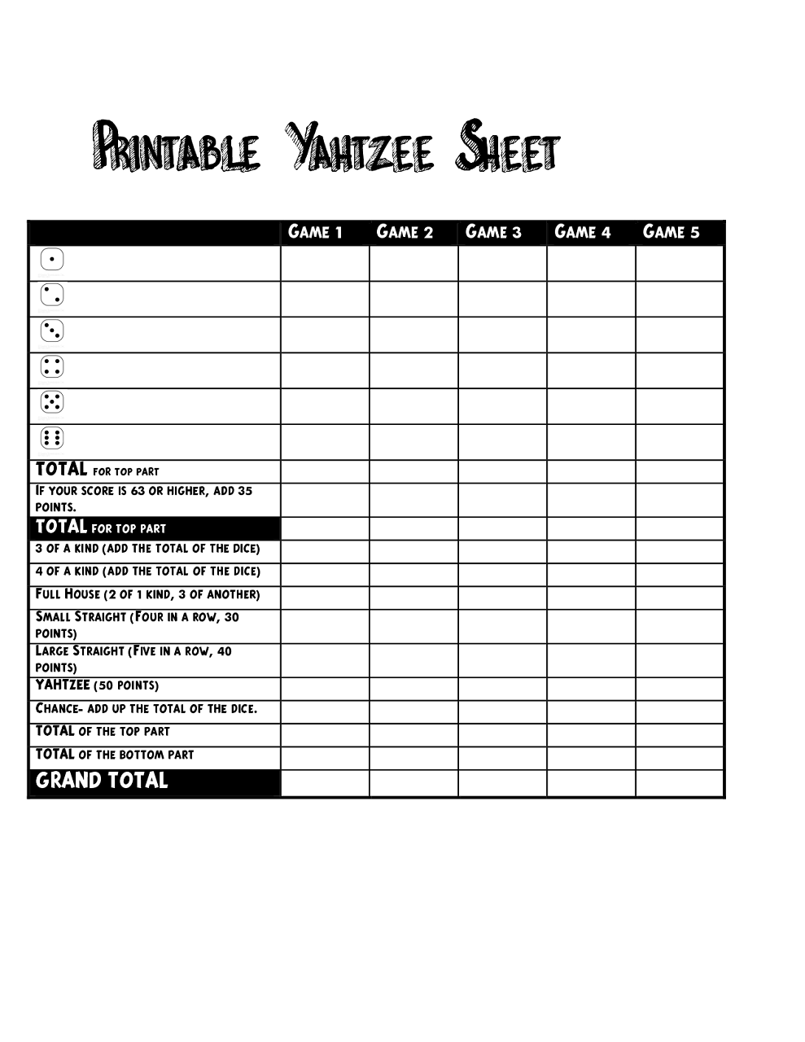

PRINTABLE YAHTZEE SHEET