Worksheet Template

Write the Initial Letter

Complete the fruit's name by writing the initial letter of each word.

  
  
  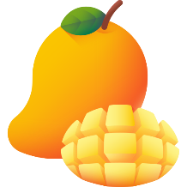
  
  
  
  
  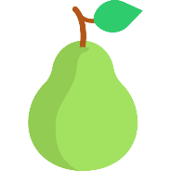
  a. | ____pple
  b. | ____trawberry
  c. | ____ango
  d. | ___atermelon
  e. | ____ananas
  f. | ____rapes
  g. | ____range
  h. | ____ear

Designed by:

© WordTemplatesOnline.net All Rights Reserved.

