Worksheet Template

Name |  |  | Class

Let’s Spell!

Circle the word that is spelled correctly for each picture

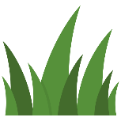 |  | Grass | Grasses | Gross
 |  | Winks | Winges | wings
 |  | Earth | Aerth | Werth
 |  | Remute | Remote | Rimote
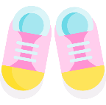 |  | Shoes | Shoese | Shoas
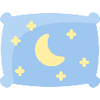 |  | Pilow | Pellow | Pillow
 |  | Flowere | Flower | Flawer

Designed by:

© WordTemplatesOnline.net All Rights Reserved.

